
ROBOT EMBEDDED PROGRAMING
Lab 4 Creating and Managing ROS 2 Workspaces and Packages

HUMBER POLYTECHNIC
FACULTY OF APPLIED SCIENCES AND TECHNOLOGY

Name:
Lance Quan
Michaël McCorkell
Percy Sanford
Tyler Brannon

Objective
In this lab, you will learn how to:
- Source a ROS 2 workspace.
- Run a custom publisher node.
- Open the turtlesim simulator.
- Observe the effect of your publisher on the turtle’s movement.
- Edit package files using Visual Studio Code (VS Code).

Prerequisites
- Ubuntu with ROS 2 Jazzy installed.
- Visual Studio Code installed.
- A workspace named turtle_py_ws.
- Package turtle_py_pkg created.

Steps 1–3: Setup
1. Verify system and ROS:
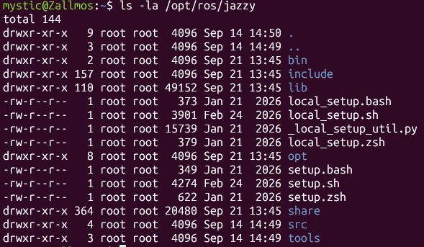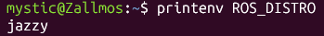
2. Running ros2 run turtlesim turtlesim_node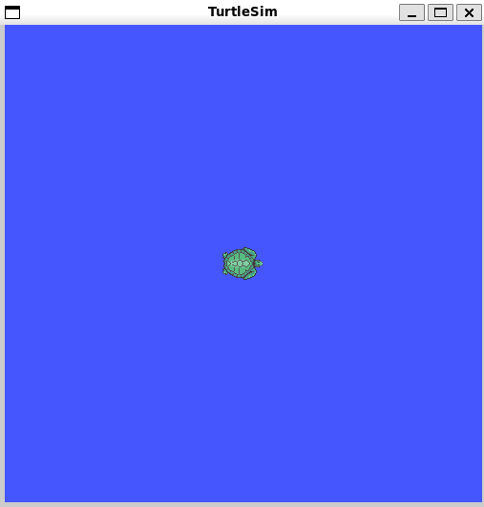
3. Creating the workspace and package: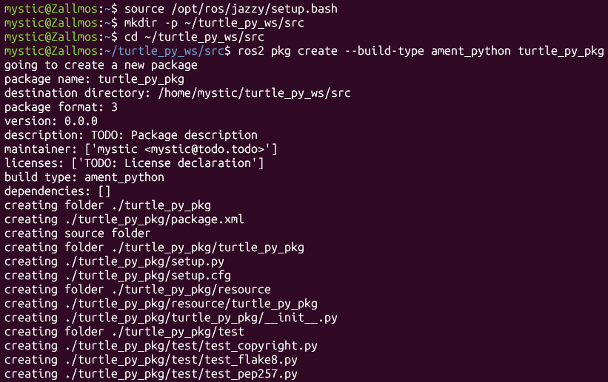

Step 4: Opening VS Code in turtle py folder
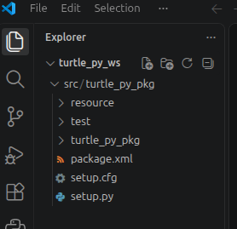

Step 5: Editing demo.py in VS Code.
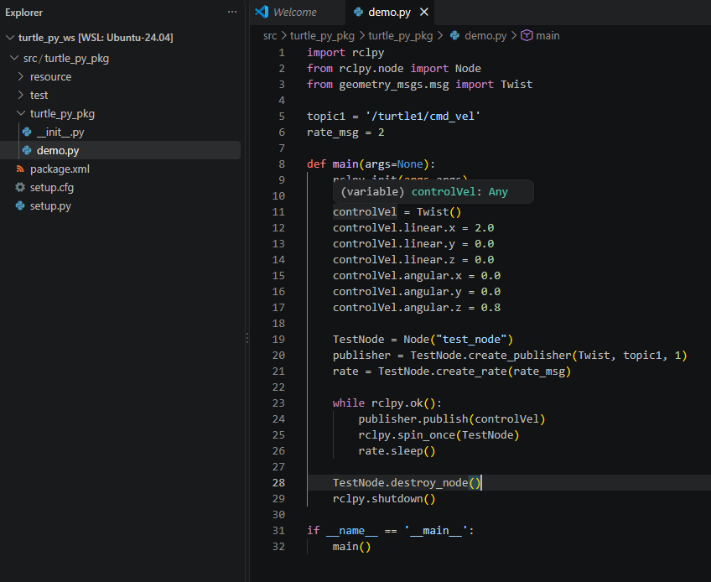

Step 6: Editing package.xml in VS Code.
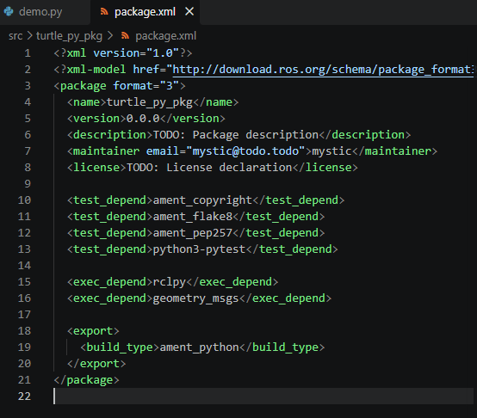

Step 7: Editing setup.py in VS Code.
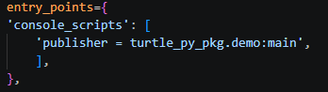

Step 8: Build the Package from edited codes from steps 5-7
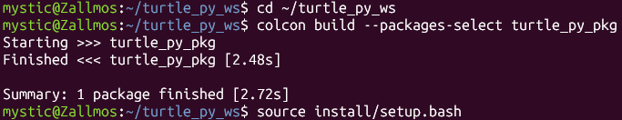

Step 9: Running the Publisher
Terminal 1:
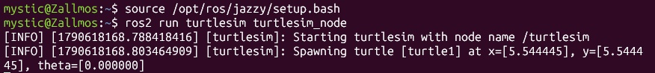
Terminal 2:

Step 10: Watching the turtle move
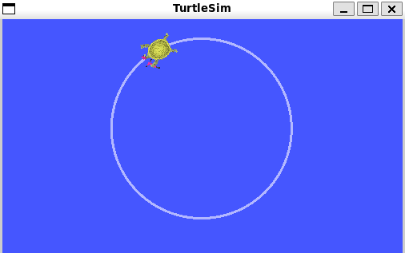
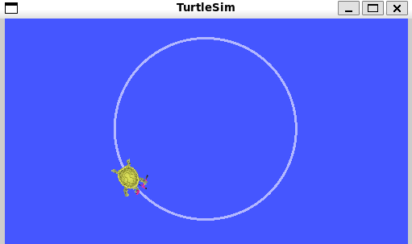

Additional Experiments:
Angular speed change: Editing demo.py in VS Code.
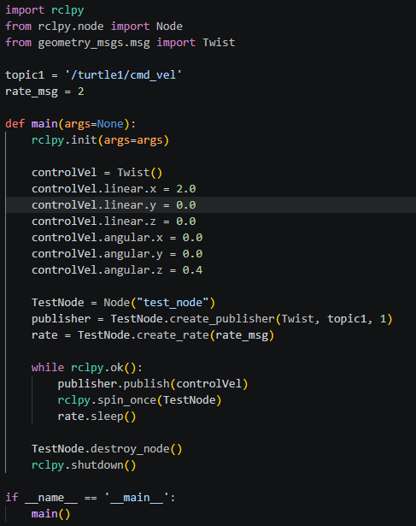
Rebuild and run again. Observe the turtle’s motion. Describe the difference compared to the original 0.8 setting
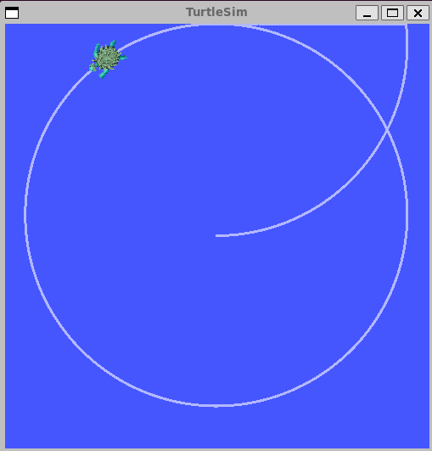
Compared to the original controlVel.angular.z setting of 0.8, changing it to 0.4 affects the size of the circular path in the simulation. With the original 0.8 setting, the robot turns more sharply, resulting in a smaller circular path. When the value is reduced to 0.4, the robot turns more gradually, creating a larger circular path with a wider angle of travel. This difference is also noticeable when the robot approaches the simulation boundaries, which act like walls. With the 0.8 setting, the smaller circle keeps the robot closer to the center, while with 0.4, the wider circular path allows the robot to travel farther toward the boundaries.
Linear speed change: Editing demo.py in VS Code.
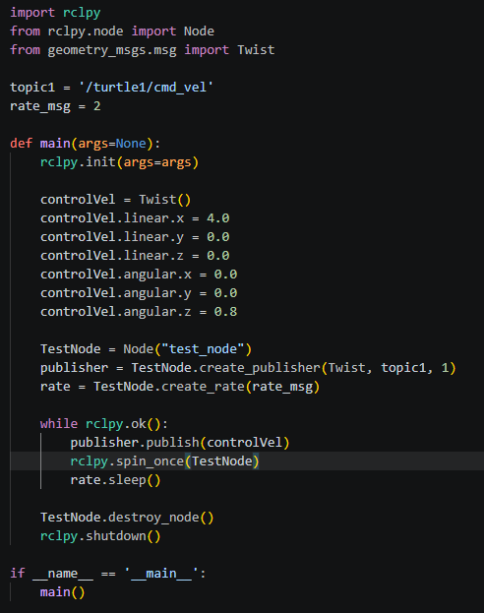
Rebuild and run again. Describe how the turtle’s path changes compared to the default.
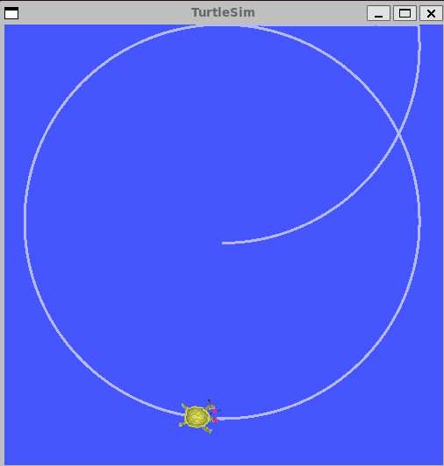
After rebuilding and running the simulation again, the turtle’s path appears similar to the path observed when controlVel.angular.z was changed to 0.4. Compared to the default settings, the turtle follows a wider circular path and travels at a larger turning angle. The overall movement pattern remains circular, but the turtle covers a larger area of the simulation instead of making a tighter circle.

3. Answer the following questions:
- In the ROS 2 publish/subscribe model, what role does the publisher node play and how does the subscriber receive data?
- The publisher node creates and sends messages containing data to a specific topic. For example, a ROS 2 node can publish a Twist message containing the turtle's linear and angular velocity.
- The subscriber listens to the topic and receives the messages published there. When a new message is published, the subscriber's callback function processes the data and uses it to perform an action.
- Why must every new terminal running a ROS 2 node source the install/setup.bash file?
Each new terminal starts with its own shell environment. Running: source install/setup.bash loads the ROS 2 workspace's environment variables, packages, nodes, and executables so ROS 2 can find and run the nodes you built in that workspace.
- What is the effect of changing the linear velocity vs. the angular velocity in the Twist message on the turtle’s path?
- Linear velocity controls how fast the turtle moves forward. Increasing it makes the turtle travel faster and, for a given angular velocity, generally produces a larger-radius path.
- Angular velocity controls how quickly the turtle turns. Increasing it makes the turtle turn more sharply, producing a smaller circular path. Decreasing it produces a wider/larger circular path.

